**МІНІСТЕРСТВО ОСВІТИ І НАУКИ УКРАЇНИ**

**НАЦІОНАЛЬНИЙ ТЕХНІЧНИЙ УНІВЕРСИТЕТ УКРАЇНИ**

**«КИЇВСЬКИЙ ПОЛІТЕХНІЧНИЙ ІНСТИТУТ ім. Ігоря Сікорського»**

**ФІЗИКО-ТЕХНІЧНИЙ ІНСТИТУТ**

**Протокол**

**до лабораторної роботи №1**

**з Методiв Обчисленнь**

**«**Розв’язання нелiнiйних рiвнянь**»**

Підготував:

студент групи ФІ-83

Яценко Артем Ігорович

Викладач:

Стьопочкіна Ірина Валеріївна

Перевірено:_____________________

**Київ – 2021**

# Варiант 6 (=16 mod 10):

$P\left(x\right)=2x^{3}−4x^{2}−x+2$

# Графiчне представлення

Графiк функцii з вказаними на ньому коренями побудовано за допомогою веб-сервiсу [desmos.com](https://www.desmos.com/calculator?lang=ru)

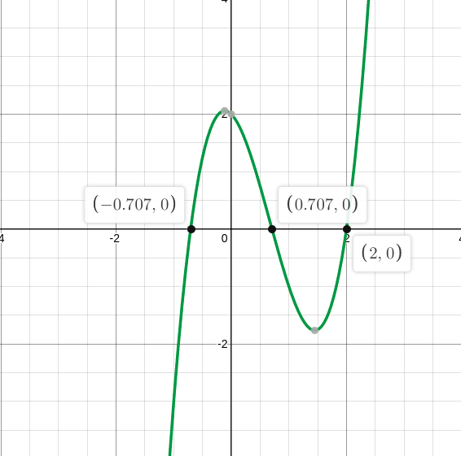

# Допрограмовий етап

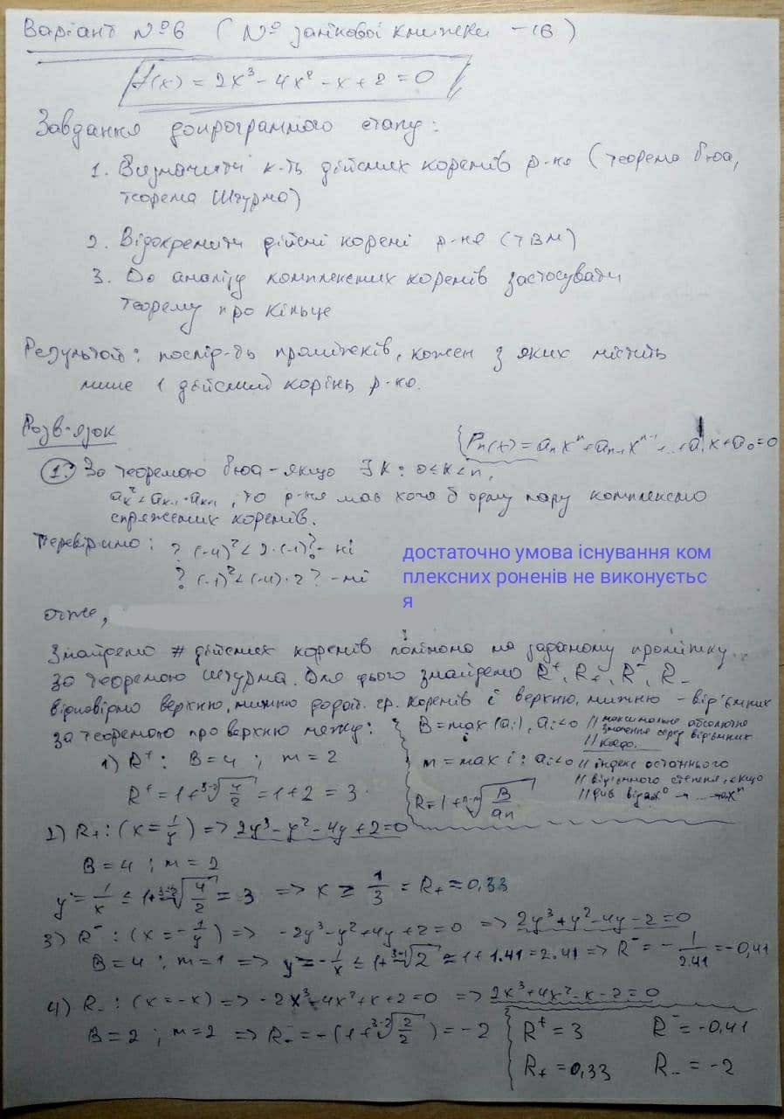

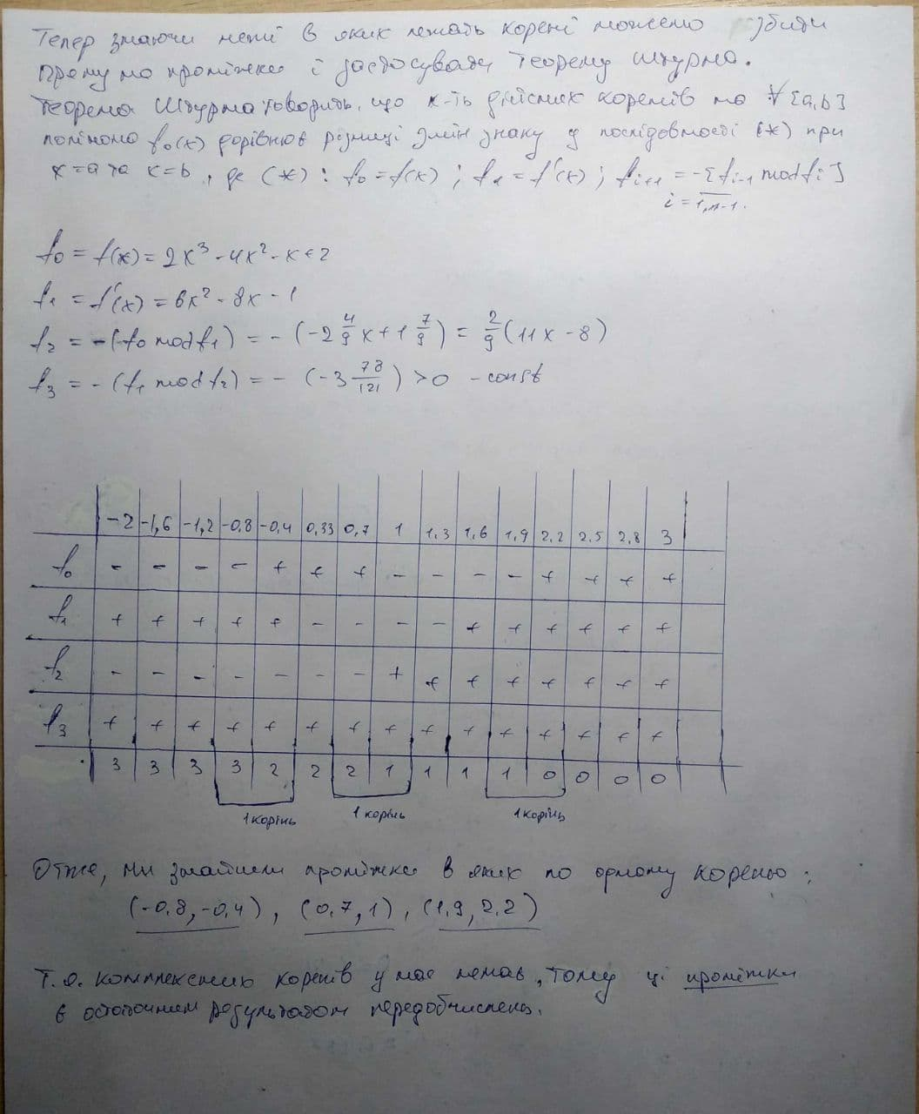

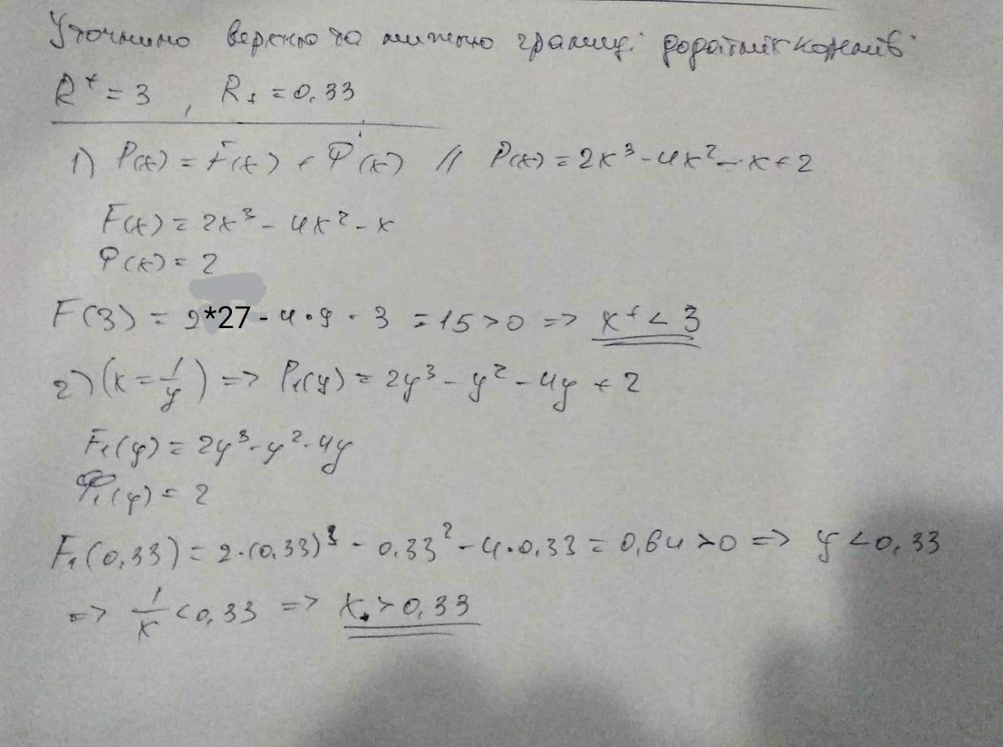

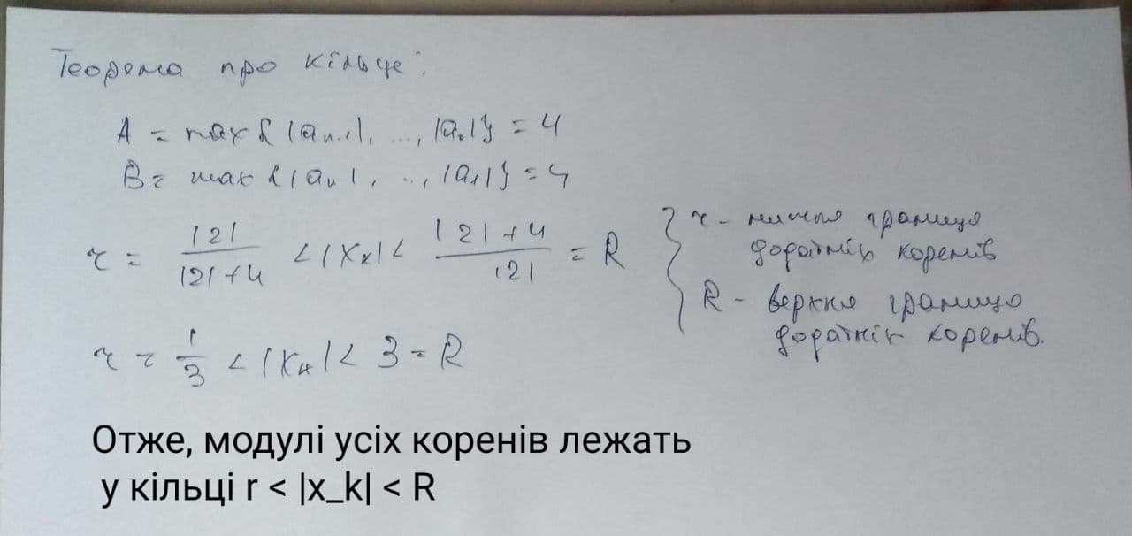

Результат:

(-0.8, -0.4)

(0.7, 1)

(1.9, 2.2)

# Аналiз. Код

bisect_meth(-0.8,-0.4)

|  |  |  |
| --- | --- | --- |
| Iteration | f(c) | ? |a-b| < e ? |
| 1 | f(-0.6000000000000001) = 0.7279999999999995 | |-0.8 - -0.6000000000000001| < 0.001 - False |
| 2 | f(-0.7000000000000001) = 0.05399999999999938 | |-0.8 - -0.7000000000000001| < 0.001 - False |
| 3 | f(-0.75) = -0.34375 | |-0.75 - -0.7000000000000001| < 0.001 - False |
| 4 | f(-0.7250000000000001) = -0.1396562500000007 | |-0.7250000000000001 - -0.7000000000000001| < 0.001 - False |
| 5 | f(-0.7125000000000001) = -0.04153515625000104 | |-0.7125000000000001 - -0.7000000000000001| < 0.001 - False |
| 6 | f(-0.70625) = 0.006554199218749668 | |-0.7125000000000001 - -0.70625| < 0.001 - False |
| 7 | f(-0.7093750000000001) = -0.01740985107421933 | |-0.7093750000000001 - -0.70625| < 0.001 - False |
| 8 | f(-0.7078125000000001) = -0.005407691955567007 | |-0.7078125000000001 - -0.70625| < 0.001 - False |
| **9** | **f(-0.70703125) = 0.0005782842636108398** | **|-0.7078125000000001 - -0.70703125| < 0.001 - True** |

bisect_meth(0.7, 1)

|  |  |  |
| --- | --- | --- |
| Iteration | f(c) | ? |a-b| < e ? |
| 1 | f(0.85) = -0.5117499999999997 | |0.7 - 0.85| < 0.001 - False |
| 2 | f(0.7749999999999999) = -0.24653124999999942 | |0.7 - 0.7749999999999999| < 0.001 - False |
| 3 | f(0.7374999999999999) = -0.11086328124999989 | |0.7 - 0.7374999999999999| < 0.001 - False |
| 4 | f(0.71875) = -0.04254150390625 | |0.7 - 0.71875| < 0.001 - False |
| 5 | f(0.709375) = -0.008293273925781275 | |0.7 - 0.709375| < 0.001 - False |
| 6 | f(0.7046874999999999) = 0.008848350524902626 | |0.7046874999999999 - 0.709375| < 0.001 - False |
| 7 | f(0.70703125) = 0.00027620792388916016 | |0.70703125 - 0.709375| < 0.001 - False |
| 8 | f(0.708203125) = -0.0040088752508165015 | |0.70703125 - 0.708203125| < 0.001 - False |
| **9** | **f(0.7076171875) = -0.001866418018936944** | **|0.70703125 - 0.7076171875| < 0.001 - True** |

bisect_meth(1.9, 2.2)

|  |  |  |
| --- | --- | --- |
| Iteration | f(c) | ? |a-b| < e ? |
| 1 | f(2.05) = 0.37024999999999597 | |1.9 - 2.05| < 0.001 - False |
| 2 | f(1.9749999999999999) = -0.17003125000000097 | |1.9749999999999999 - 2.05| < 0.001 - False |
| 3 | f(2.0124999999999997) = 0.0887539062499978 | |1.9749999999999999 - 2.0124999999999997| < 0.001 - False |
| 4 | f(1.99375) = -0.043437988281251005 | |1.99375 - 2.0124999999999997| < 0.001 - False |
| 5 | f(2.003125) = 0.021953186035152505 | |1.99375 - 2.003125| < 0.001 - False |
| 6 | f(1.9984374999999999) = -0.010917976379396066 | |1.9984374999999999 - 2.003125| < 0.001 - False |
| 7 | f(2.0007812499999997) = 0.005473633766175379 | |1.9984374999999999 - 2.0007812499999997| < 0.001 - False |
| 8 | f(1.999609375) = -0.0027331544160857923 | |1.999609375 - 2.0007812499999997| < 0.001 - False |
| **9** | **f(2.0001953125) = 0.001367492690680372** | **|1.999609375 - 2.0001953125| < 0.001 - True** |

hord_meth(-0.8,-0.4)

|  |  |  |
| --- | --- | --- |
| Iteration | f(c) | ? |c - c_prev| < e ? |
| 1 | f(-0.6701986754966888) = 0.2714723456709085 | |-0.6701986754966888 - -0.8| < 0.001 - False |
| 2 | f(-0.7035841736375292) = 0.026869899020840693 | |-0.7035841736375292 - -0.6701986754966888| < 0.001 - False |
| 3 | f(-0.7067791171438782) = 0.002507990927270054 | |-0.7067791171438782 - -0.7035841736375292| < 0.001 - False |
| **4** | **f(-0.7070763768426126) = 0.00023279401042142212** | **|-0.7070763768426126 - -0.7067791171438782| < 0.001 - True** |

hord_meth(0.7, 1)

|  |  |  |
| --- | --- | --- |
| Iteration | f(c) | ? |c - c_prev| < e ? |
| 1 | **f(0.7076023391812866) = -0.0018121235283872217** | |0.7076023391812866 - 0.7| < 0.001 - False |
| **2** | **f(0.7071070020421742) = -8.076368254172905e-07** | **|0.7071070020421742 - 0.7076023391812866| < 0.001 - True** |

hord_meth(1.9, 2.2)

|  |  |  |
| --- | --- | --- |
| Iteration | f(c) | ? |a-b| < e ? |
| 1 | f(1.9791348600508907) = -0.14259131456998864 | |1.9791348600508907 - 1.9| < 0.001 - False |
| 2 | f(1.995899257077413) = -0.028570809634917538 | |1.995899257077413 - 1.9791348600508907| < 0.001 - False |
| 3 | f(1.9992039266551633) = -0.005567444560688362 | |1.9992039266551633 - 1.995899257077413| < 0.001 - False |
| **4** | **f(1.999845831744652) = -0.0010789876519576858** | **|1.999845831744652 - 1.9992039266551633| < 0.001 — True** |

neuton_meth(-0.8)

x0 = a

|  |  |  |
| --- | --- | --- |
| Iteration | f(c) | ? |a-b| < e ? |
| 0 | f(-0.8) = -0.7840000000000007 | |-0.8 - -0.7151515151515151| < 0.001 - False |
| 1 | f(-0.7151515151515151) = -0.06213184183432041 | |-0.7151515151515151 - -0.7071755279300581| < 0.001 - False |
| **2** | **f(-0.7071755279300581) = -0.0005264227515033859** | **|-0.7071755279300581 - -0.7071067862736496| < 0.001 - True** |

neuton_meth(-0.4)

x0 = b

|  |  |  |
| --- | --- | --- |
| Iteration | f(c) | ? |a-b| < e ? |
| 0 | f(-0.4) = 1.632 | |-0.4 - -0.9164556962025316| < 0.001 - False |
| 1 | f(-0.9164556962025316) = -1.9825543374864867 | |-0.9164556962025316 - -0.7421037691732579| < 0.001 - False |
| 2 | f(-0.7421037691732579) = -0.2781480610795546 | |-0.7421037691732579 - -0.7083525985160282| < 0.001 - False |
| 3 | f(-0.7083525985160282) = -0.009551838660144973 | |-0.7083525985160282 - -0.7071084485234023| < 0.001 - False |
| **4** | **f(-0.7071084485234023) = -1.2766578196377054e-05** | **|-0.7071084485234023 - -0.7071067811895402| < 0.001 - True** |

neuton_meth(0.7)

x0 = a

|  |  |  |
| --- | --- | --- |
| Iteration | f(c) | ? |a-b| < e ? |
| 0 | f(0.7) = 0.026000000000000023 | |0.7 - 0.707103825136612| < 0.001 - False |
| **1** | **f(0.707103825136612) = 1.080984588885947e-05** | **|0.707103825136612 - 0.7071067811859678| < 0.001 - True** |

neuton_meth(1)

x0 = b

|  |  |  |
| --- | --- | --- |
| Iteration | f(c) | ? |a-b| < e ? |
| 0 | f(1) = -1 | |1 - 0.6666666666666667| < 0.001 - False |
| 1 | f(0.6666666666666667) = 0.14814814814814792 | |0.6666666666666667 - 0.7070707070707071| < 0.001 - False |
| **2** | **f(0.7070707070707071) = 0.00013191809947254995** | **|0.7070707070707071 - 0.7071067811002523| < 0.001 - True** |

neuton_meth(1.9)

x0 = a

|  |  |  |
| --- | --- | --- |
| Iteration | f(c) | ? |a-b| < e ? |
| 0 | f(1.9) = -0.6220000000000012 | |1.9 - 2.013919413919414| < 0.001 - False |
| 1 | f(2.013919413919414) = 0.09899129188200462 | |2.013919413919414 - 2.0002160597500422| < 0.001 - False |
| **2** | **f(2.0002160597500422) = 0.0015127917249904144** | **|2.0002160597500422 - 2.000000053330071| < 0.001 - True** |

neuton_meth(2.2)

x0 = b

|  |  |  |
| --- | --- | --- |
| Iteration | f(c) | ? |a-b| < e ? |
| 0 | f(2.2) = 1.7360000000000033 | |2.2 - 2.0337164750957855| < 0.001 - False |
| 1 | f(2.0337164750957855) = 0.24518638903807632 | |2.0337164750957855 - 2.0012254668251184| < 0.001 - False |
| 2 | f(2.0012254668251184) = 0.008590285608079729 | |2.0012254668251184 - 2.0000017125597993| < 0.001 - False |
| **3** | **f(2.0000017125597993) = 1.1987942057256618e-05** | **|2.0000017125597993 - 2.000000000003352| < 0.001 - True** |

**Код:**

# 2*x^3 -4*x^2 - x + 2 = 0

def f(x):

return 2*(x**3) - 4*(x**2) - x + 2

def df(x):

return 6*(x**2) - 8*x - 1

def bisect_meth(a ,b ,e=0.001):

if f(a)*f(b) < 0:

i = 1

while abs(a-b) > e:

c = (a+b) / 2

if f(c)*f(a) < 0:

b = c

elif f(c)*f(b) < 0:

a = c

print(f'№{i} f({c}) = {f(c)} |{a} - {b}| < {e} - {"False" if abs(a-b) > e else "True"}')

i+=1

return (a+b) / 2

def hord_meth(a,b,e=0.001):

if f(a)*f(b) < 0:

c = a

c_prev = 0

i = 1

while abs(c - c_prev) > e:

c_prev = c

num = a*f(b) - b*f(a)

denum = f(b) - f(a)

c = num / denum

if f(c)*f(a) < 0:

b = c

elif f(c)*f(b) < 0:

a = c

print(f'№{i} f({c}) = {f(c)} |{c} - {c_prev}| < {e} - {"False" if abs(c-c_prev) > e else "True"}')

i+=1

return c

def neuton_meth(x0,e=0.001):

x = x0

x_next = x0 - (f(x0)/df(x0))

print(f'№{0} f({x}) = {f(x)} |{x} - {x_next}| < {e} - {"False" if abs(x - x_next) > e else "True"}')

i = 1

while abs(x - x_next) > e:

x = x_next

x_next = x - (f(x)/df(x))

print(f'№{i} f({x}) = {f(x)} |{x} - {x_next}| < {e} - {"False" if abs(x - x_next) > e else "True"}')

i+=1

return x_next

def choose_method():

print('1 - Bisection method')

print('2 - Chord method')

print('3 - Newton\'s method')

def choose_interval():

print('1 - (-0.8, -0.4)')

print('2 - (0.7, 1)')

print('3 - (1.9, 2.2)')

def main():

choose_method()

choise = int(input('Choose method:'))

if choise == 1:

choose_interval()

choise = int(input('Choose interval:'))

if choise == 1:

print(f'Result = {bisect_meth(-0.8,-0.4)}')

elif choise == 2:

print(f'Result = {bisect_meth(0.7, 1)}')

elif choise == 3:

print(f'Result = {bisect_meth(1.9,2.2)}')

else:

print("Wrong input")

elif choise == 2:

choose_interval()

choise = int(input('Choose interval:'))

if choise == 1:

print(f'Result = {hord_meth(-0.8,-0.4)}')

elif choise == 2:

print(f'Result = {hord_meth(0.7, 1)}')

elif choise == 3:

print(f'Result = {hord_meth(1.9,2.2)}')

else:

print("Wrong input")

elif choise == 3:

choose_interval()

choise = int(input('Choose interval:'))

if choise == 1:

print(f'1 - a = -0.8')

print(f'2 - b = -0.4')

choise = int(input('Choose initial approximation:'))

if choise == 1:

print(neuton_meth(-0.8))

elif choise == 2:

print(neuton_meth(-0.4))

else:

print('Wrong input')

elif choise == 2:

print(f'1 - a = 0.7')

print(f'2 - b = 1')

choise = int(input('Choose initial approximation:'))

if choise == 1:

print(neuton_meth(0.7))

elif choise == 2:

print(neuton_meth(1))

else:

print('Wrong input')

elif choise == 3:

print(f'1 - a = 1.9')

print(f'2 - b = 2.2')

choise = int(input('Choose initial approximation:'))

if choise == 1:

print(neuton_meth(1.9))

elif choise == 2:

print(neuton_meth(2.2))

else:

print('Wrong input')

else:

print('Wrong input')

if __name__ == "__main__":

main()